Valery I. Kurir
KNITU-KAI, senior lecturer, cand. of tech. sciences,
RF, Kazan, kurir_valerian@mail.ru).

THE ROLE OF THE MATLAB/SIMULINK PACKAGE IN DIPLOMA DESIGN

An overview of works devoted to the problems of design and numerical modeling of the power supply system of aircraft − aircraft PSS in the Matlab / Simulink package, carried out by Russian and foreign researchers, is given.
Key words: aircraft power supply systems, modeling the operation of aircraft power supply systems in the Matlab / Simulink package.

The paper presents an overview of the works devoted to the numerical modeling of the aircraft PSS, which is of interest to specialists dealing with this topic. Monographs [1 − 3] will be used as starting guides for carrying out numerical calculations of power electronics systems, as well as the electric drive of electromechanical systems in the Matlab / Simulink package.
Currently, in aviation, a three-phase AC 115/200 V system with a constant frequency of 400 Hz with a semiconductor converter (PP or FC) is used. A promising high voltage constant current system is ± 270 V [4].
The authors of [4] consider a system for generating low voltage direct current as promising, where the functions of a PCB (semiconductor converter) are performed by a voltage rectifier made on a modular basis on MOSFET transistors (Fig. 1).
The authors of [4] adopted a system for generating a current of a stable frequency of 400 Hz and a voltage of 115 V as a promising alternating current system for PSS aircraft (Fig. 2).
An aircraft with enhanced equipment electrification (EEC) is an aircraft in which thrust is created by traditional engines, and a large mass of equipment receives energy from a centralized PSS of the aircraft. The scheme of the PSS of the aircraft, in which this concept is implemented, is presented by the authors of [5] in (Fig. 3). The aircraft, the thrust in which is created using an electric power plant, is called a fully electric aircraft (FEA) [6]. An aircraft with a mixed thrust is called a hybrid aircraft [7].
Let us turn to the work carried out by Russian and foreign researchers towards an aircraft with increased electrification, who used the Matlab simulation package in their work.

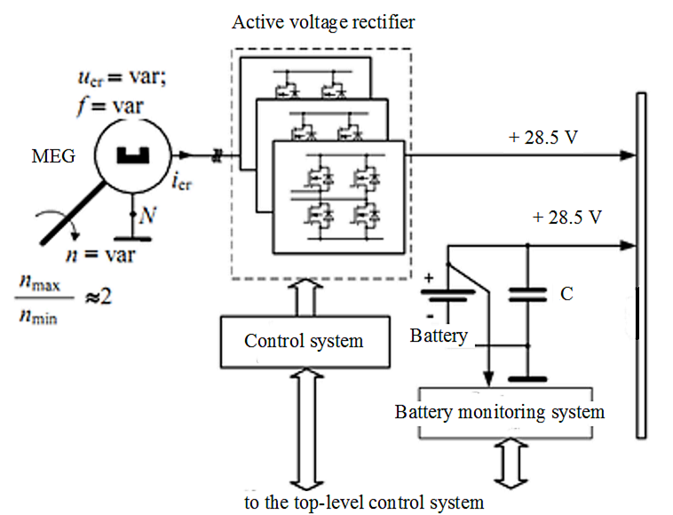

Fig. 1. DC generation system with AVR

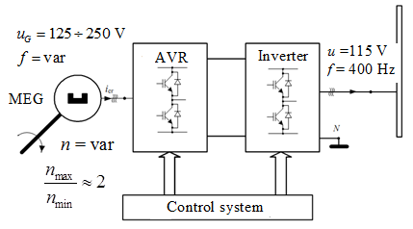

Fig. 2. The system for generating alternating current of a stable frequency of 400 Hz and a voltage of 115 V
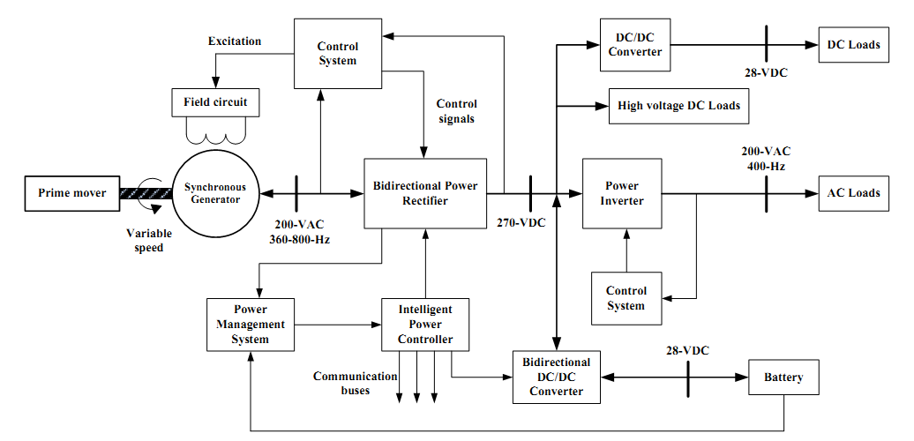

Fig. 3. Electricity distribution system of aircraft with increased electrification

In work [8], a regular replacement of an electric drive EPPZ−334 of a similar hydraulic drive of the wing mechanization movement system − SPMK−9 of an aircraft was carried out. The author of [9] has developed a magnetoelectric synchronous MEG generator with a capacity of at least 200 kV ∙ A and more alternating current, which serves as an SG starter-generator. In [10], a high-voltage direct current electric generator with a capacity of up to several hundred kilowatts was developed with a direct drive from an aircraft engine operating in a system with an electronic converter. The author [11] has developed and numerically modeled a backup system for generating electrical energy based on a magnetoelectric generator and a voltage inverter, built using a modular principle.
The basics of simulation modeling of PSS aircraft in the Matlab package are presented in the monograph [12]. The work [13] presents a model of a synchronous machine − SM with a damper winding, further calculated in the Matlab package. A model of synchronous connection of generators to a single network has been investigated. The authors of [14] developed a refined model of a synchronous generator − SG, presented in the form of three machines: the exciter, the exciter and the generator itself. The results of modeling in the Matlab package are presented. In [15], the SG model is presented by a system of matrix equations. The block diagrams of the voltage regulator and constant speed drive are given. The PSS aircraft model is implemented in the Matlab / Simulink package.
The authors of [16] presented the results of simulation modeling of the power unit of the PSS of fully electric aircraft in the Matlab / Simulink package. The authors of [17] simulated the PSS of the Il − 76 aircraft in the Simulink package. Models of PSS of alternating and direct currents, their elements, simulation results are presented. In [18], simulation modeling was carried out in the Matlab / Simulink package for DC PSS of the Su-30SM aircraft in normal and emergency operating modes. The authors of [19] developed a simulation model of the PSS of the Su-27 aircraft in the Matlab / Simulink package. It allows you to explore the PSS of the aircraft both in normal and emergency operating modes. The author of [20] carried out a simulation of the operation of AC and DC systems of the PSS of IL−76 aircraft in the Matlab / Simulink package. In [21], a model of a power supply system for a promising long-range aircraft in the SimInTech software package is considered. The results of modeling a four-channel system for generating and distributing AC power during normal operation are presented.
In the article [22], the simulation of the propulsion mode of a starter-generator set for an aircraft gas turbine engine in the Matlab / Simulink package was carried out. A permanent magnet synchronous motor is used as an electrical machine.
The author of [23] presents a system for regulating the frequency of the output voltage of a synchronous generator, developed on the basis of fuzzy logic using a genetic algorithm that allows optimizing the characteristics of the frequency regulator.
The work [24] presents a methodology for designing of an aircraft PSS. The tasks required for the implementation of automation of the design process of the aircraft PSS are listed. The authors of [25] presented the modeling of the PSS for aircraft of Bombardier Global Express aircraft in the Simulink package (an autonomous implementation model) and the OPAL−RT solver (for real-time modeling). The authors of [26] presented a cross-platform methodology for designing an aircraft solar power plant. The packages used to simulate the operating modes of the PSS aircraft − Matlab / Simulink and Modelica.

References

1. Herman-Galkin S. G. Computer modeling of semiconductor systems in MATLAB 6.0: Textbook. − SPb: KORONA print, 2001.− 2001. − 320 p (in Russian).
2. German − Galkin S.G. MATLAB & Simulink. MATLAB & Simulink. Designing mechatronic systems on a PC. – SPb.: KORONA−Vek, − 2008. − 368 p (in Russian).
3. Chernykh I.V. Simulation of electrical devices in MATLAB SymPowerSystems and Simulink. − Moscow: DMK Press, 2012. − 288 p (in Russian).
4. Garganeyev A.S., Kharitonov S.A. Promising power supply systems with fully electrified equipment // Reports of TUSUR. - 2009. − No. 2 (20). − p. 185 – 192 (in Russian).
5. Bocharov V.V., Postnikov V.A., Reznikov S.B., Kharchenko A.I. Energyeconomical combined system with high power quality for the concept of "fully electrified aircraft" // Electronic the journal «Proceedings of the MAI».− 2012. − No 58. – 19 p (in Russian).
6. Khalyutin S.P. Electric plane: past, present, future // Aviapanorama. − 2016. − No 6. – pp. 42 – 51 (in Russian).
7. Khalyutin S.P., Davidov O.A., Zhmurov B.V. Electric and Hybrid Aircraft: Prospects for Creation // Electricity. − 2017. − No 9. – pp. 4 −16 (in Russian).
8. Volokitina Ye.V. Research and development of a high-speed valve electric drive for controls of new aircraft. Diss. Cand. tech. Sciences / Chuvash. state un-t. − Cheboksary, 2006.
– 197 p (in Russian).
9. Vlasov A.I. Magnetoelectric starter − generator in the power supply system of new generation aircraft. Diss. Cand. tech. Sciences / Chuvash. state un-t. − Cheboksary, 2010. − 260 p (in Russian).
10. Kuz'michev R.V. Generator in the power supply system of a promising aircraft with an increased level of electrification. Diss. Cand. tech. Sciences / Moscow Aviation Institute – Moscow, 2012 .− 193 p (in Russian).
11. Mashinskiy V.V. Backup system for generating electrical energy for aircraft. Diss. Cand. tech. Sciences / Novosib. state tech. university. − Novosibirsk, 2014. − 134 p (in Russian).
12. Khalyutin S.P., Tyulyayev M.L, Zhmurov B.V., Starostin I.Ye. Simulation of complex electric power systems of aircraft / Military Air Academy named after prof. N.E. Zhukovsky and Yu.A. Gagarin. Moscow – 2010. − 188 p (in Russian).
13. Demchenko A.G., Artomenko YU.P. Simulation of parallel operation of the on-board AC power supply system in the Matlab package // Scientific Bulletin of MSTU GA. − 2012. − No 185. – pp. 55 −60 (in Russian).
14. Artemenko YU.P., Sharapov S.S. Application of Matlab in modeling an on-board AC power supply system // Bulletin of MSTU GA. – 2012. – No 185. – pp. 77 – 84 (in Russian).
15. Artemenko YU.P., Demchenko S.S. Improving the model of the on-board AC power supply system // Scientific Bulletin of MSTU GA. − 2015 – No 213. – pp. 34 – 42 (in Russian).
16. Zhmurov B.V., Matyushina A.V., Sokolov P.A. Modeling the operating modes of power supply centers for electric drives of a fully electrified aircraft // Bulletin of MSTU GA. − 2012. – No 185. – pp. 99 – 103 (in Russian).
17. Bocharov A.S., Gubanov K.A., Yevdokimov YA.A. Simulation model of the electric power complex of the Il−76 aircraft in the Simulink simulation environment / Coll. scientific. Art. based on the materials of the IV All-Russian Scientific − practical conf. "Academic Zhukovsky Readings" (November 23-24, 2016), Voronezh: VUNC VVS "VVA", 2017. − pp. 32 – 39 (in Russian).
18. Abbyasov I.V., Bocharov A.S., Sharov I.V. A simulation model of an aircraft DC power supply system with the ability to study in normal and emergency modes of operation in the Simulink simulation environment / Actual problems and perspective directions of development of aviation equipment complexes / Coll. scientific. Art. based on the materials of the V All-Russian Scientific − practical conf. "Academic Zhukovsky Readings" (February 15−16, 2018): − Voronezh: VUNC VVS "VVA", 2018. − pp. 3 – 7 (in Russian).
19. Bocharov A.S., Gubanov K.A., Shipilov A.A. Automated workstation for studying and researching the power supply system of the Su−27 fighter / Actual problems and perspective directions of development of aviation equipment complexes / Coll. scientific. Art. based on the materials of the V All-Russian Scientific − practical conf. "Academic Zhukovsky Readings" (February 15−16, 2018): − Voronezh: VUNC VVS "VVA", 2017. − P. 13 – 18 (in Russian).
20. Al'chin YU.YU. Development of a simulation model of a power supply system for a heavy aircraft. Master Thesis, NTPU, Tomsk, 2018. − 103 p (in Russian).
21. Smagin D.I., Starostin K.I., Savel'yev R.S., Satin A.A, Pritulkin T.D., Methods of creating a dynamic mathematical model of an AC power supply system (PSS) of a promising long-haul passenger aircraft in the SimInTech software package // Comp. nanotechnol. − 2019. − No. 2. − pp. 57 – 62 (in Russian).
22. Korolev Ye.V., Liskovskaya Ye.V., Pavlov D.A. Calculation and modeling of a starter generator aircraft gas turbine engine // International Conference on Soft Computing, − 2020. − V.1. − pp. 296 −298 (in Russian).
23. Karimov V.G. Combined systems for regulating the frequency of the output voltage with elements of artificial intelligence for contactless synchronous generators. diss. Cand. tech. Science / Ufa State Aviation Technical University. − Ufa, 2012.− 146 p (in Russian).
24. Zhmurov B.V. The process of designing power supply systems for aircraft as an object of optimization // Scientific Bulletin of MSTU GA. − 2018. − No. 01. – pp. 88 – 103 (in Russian).
25. Montealegre Lobo L., Dufour Ch., Mahseredjian J. Real-time Simulation of More-Electric Aircraft Power Systems // Paper presented at the EPE'13 ECCE Europe conference, September 3 − 5, 2013, Lille, France. − 11 p.
26. Nuzzo P., Finn J., Mozumdar M., Sangiovanni-Vincentelli A. Platform-Based Design Methodology and Modeling for Aircraft Electric Power Systems // Paper presented at the Green Energy and System Conference, 25 Nov. 2013 Long−Beach, Ca., USA. − 7 p.

